Community Resilience to Extreme Events Exhibit

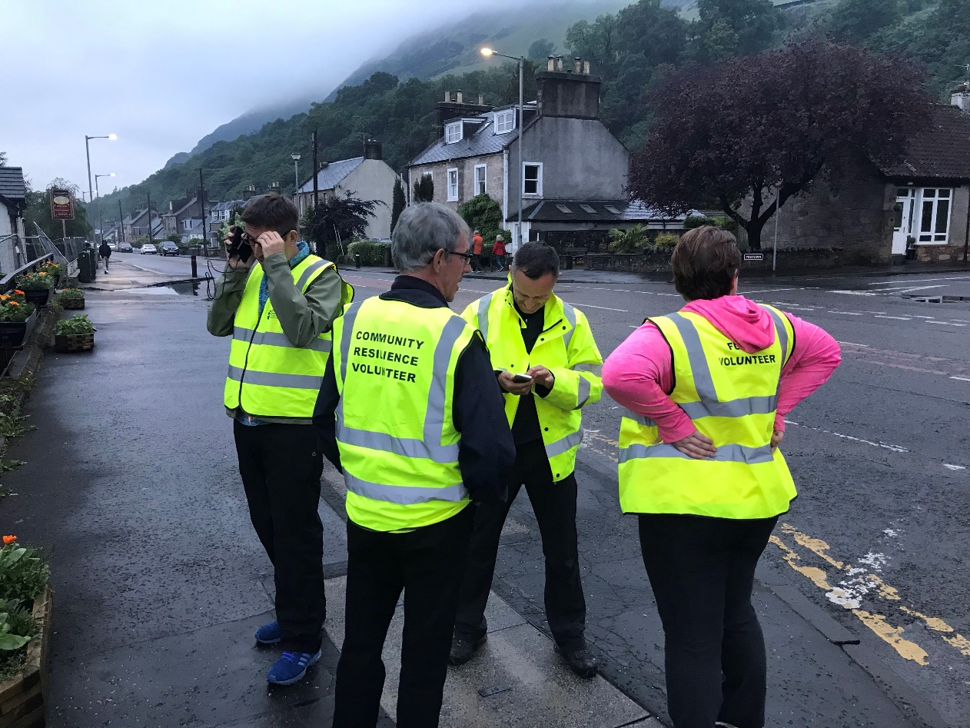

Cover photograph courtesy of James Bull and Dave Sharp, depicting the Menstrie Community Resilience Group in action
Background
The Project
There remains gaps in understanding what community resilience actually is and means to those working in communities, academia, practice and policy (and how these meanings and relevancies differ between these groups). In addition, gaps exist around what kinds of community resilience are currently enacted (particularly in Scotland) and how such experiences can be used to encourage further development of community resilience. We believe creating a network of people interested in community resilience will be the first step in building and feeding into a movement(s) around creating a fairer, healthier and more ecologically sustainable Scotland. This project was funded by the National Centre for Resilience to Sandra Engstrom, Fiona Millar and Tony Robertson (Grant ref: NCRR1819-004) and employed Andrew Ruck and Paul Docherty as Research Assistants. The project ran in 2019 and involved two research workshops, a number of one-to-one interviews and a photography exhibit. A final report will be shared publicly in late 2019.
The Photographs
As part of the project we asked for workshop participants and the wider public to submit photographs we could display that represented ‘community resilience’ and/or ‘extreme events’. The aim of this exhibit is to highlight some of the extreme events our communities face, and how these communities come together to support each other. Much of this work is not photographed and often goes on in the background, so we are thrilled to get a glimpse of what happens when resilient communities respond to extreme circumstances. All photographs have been used under Creative Commons Non Commercial (BY-NC 4.0) license.

Farm Life
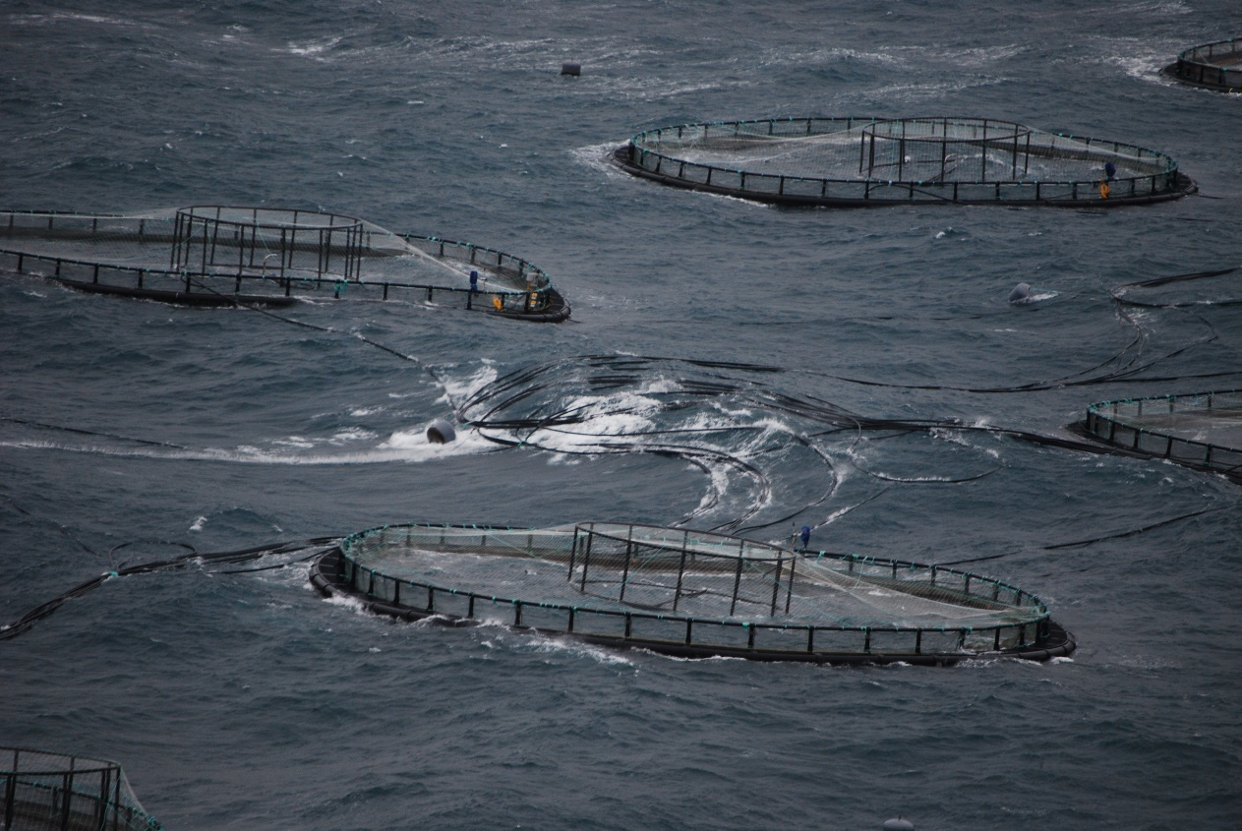

To show how extreme it can be working on a salmon farm in an off shore exposed site in Scotland. Credit: Martin Roeed and Sonia Rey Planellas

Beast from the East
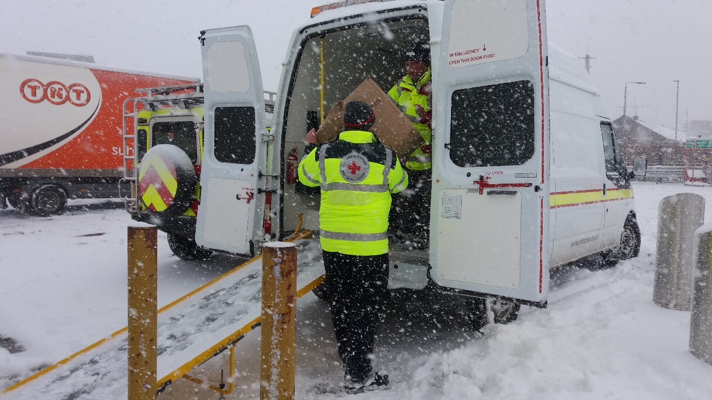

British Red Cross Emergency Response Volunteers responding during Beast from the East with beds and blankets. Credit: Nick Mort

Wellies Ready
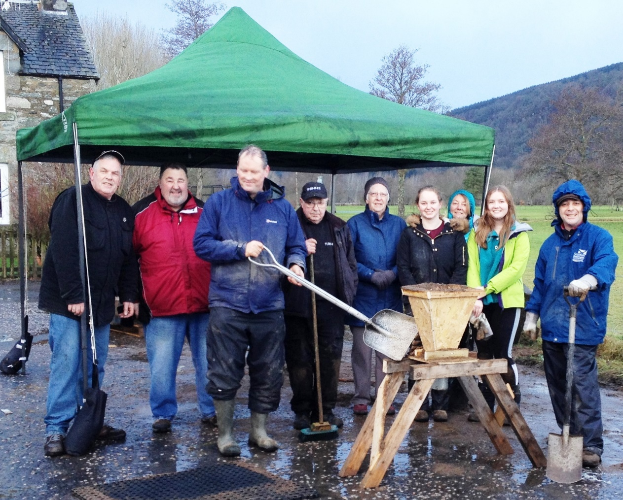

Scottish Flood Forum Community Action in Aberfeldy. Credit: Paul Laidlaw

Where Shall We Camp?
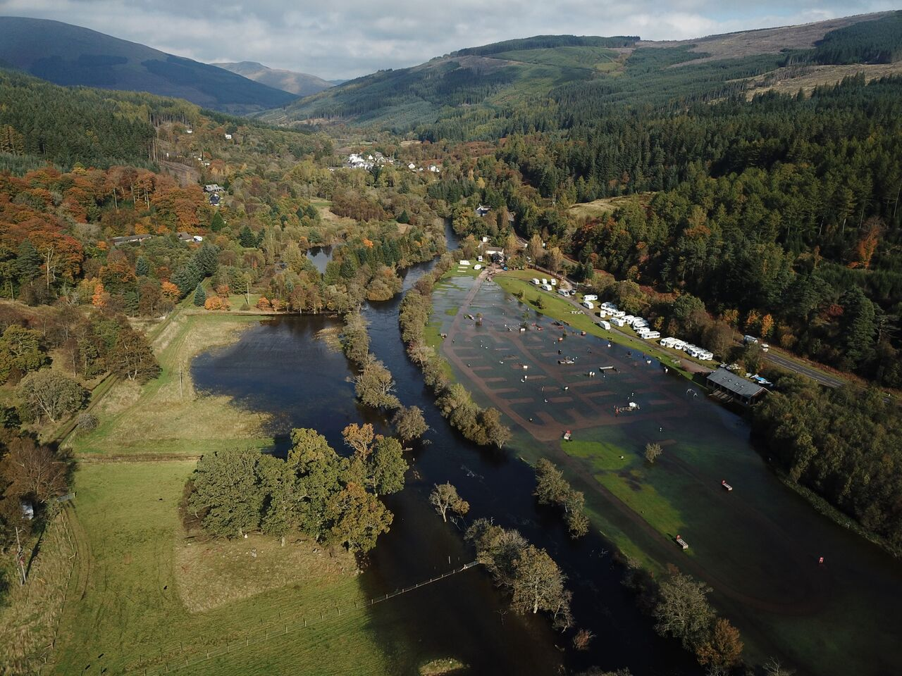

Flooding at Immervoulin campsite, Callander. Credit: K Higgins

All Roads Lead Somewhere

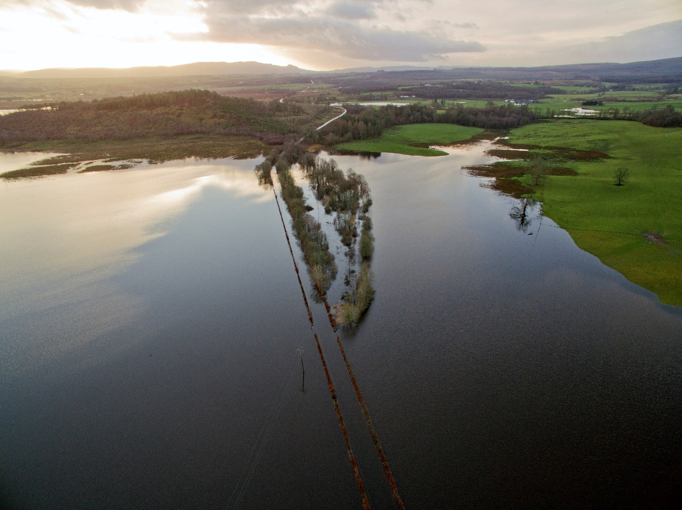

A81 Aberfoyle to Gartmore. Credit: Craig Jump

Love to London
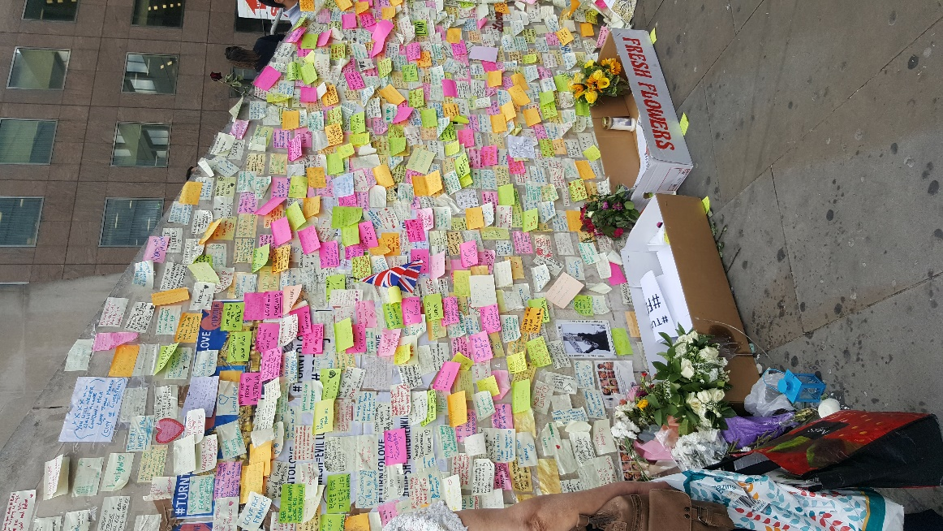
Messages of support on London Bridge after the attack in June 2017. At the time Clare worked in the Medical Library next to nearby Guy’s Hospital and took this photo on her daily walk over the bridge. An off duty nurse who worked at Guy’s lost her life helping the victims, and another was stabbed. Two years later, as the inquests make the news, the mother of one of the victims showed incredible resilience, saying "love will always win over hate…the support we've received from home in Australia and the London people is overwhelming." Credit: Clare Crowley

Welcome
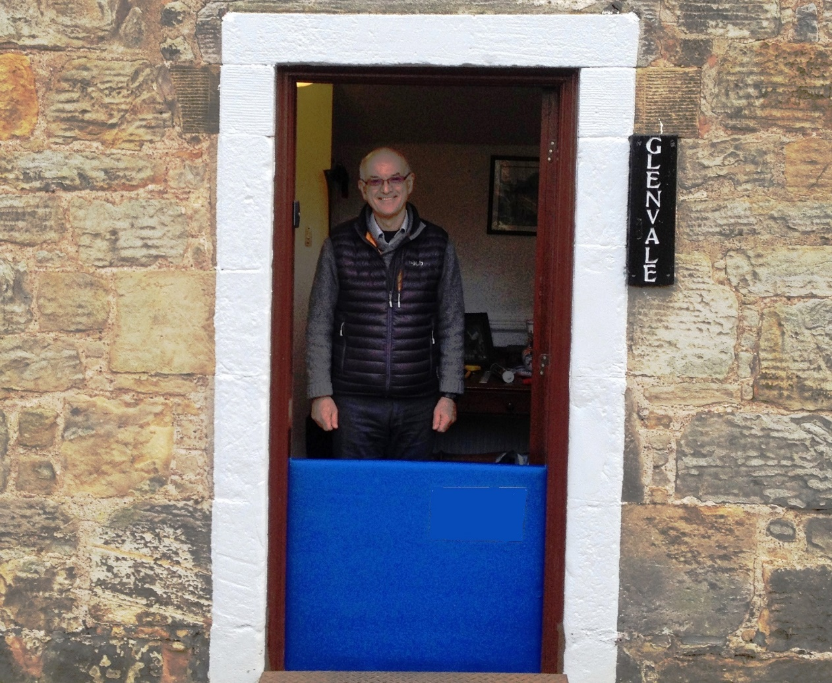

Scottish Flood Forum property floor protection in action in Falkland, Fife. Credit: Paul Laidlaw

Beach Holiday
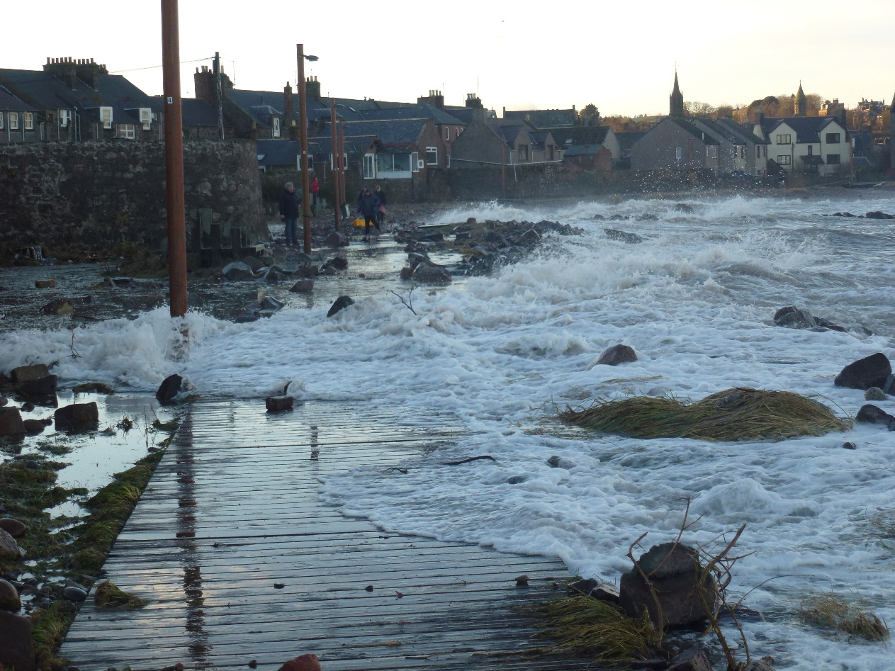

Credit: Will Munro

New Delivery

British Red Cross Community Reserve Volunteers preparing for a flood exercise. Credit: Nick Mort

Day at the Bay
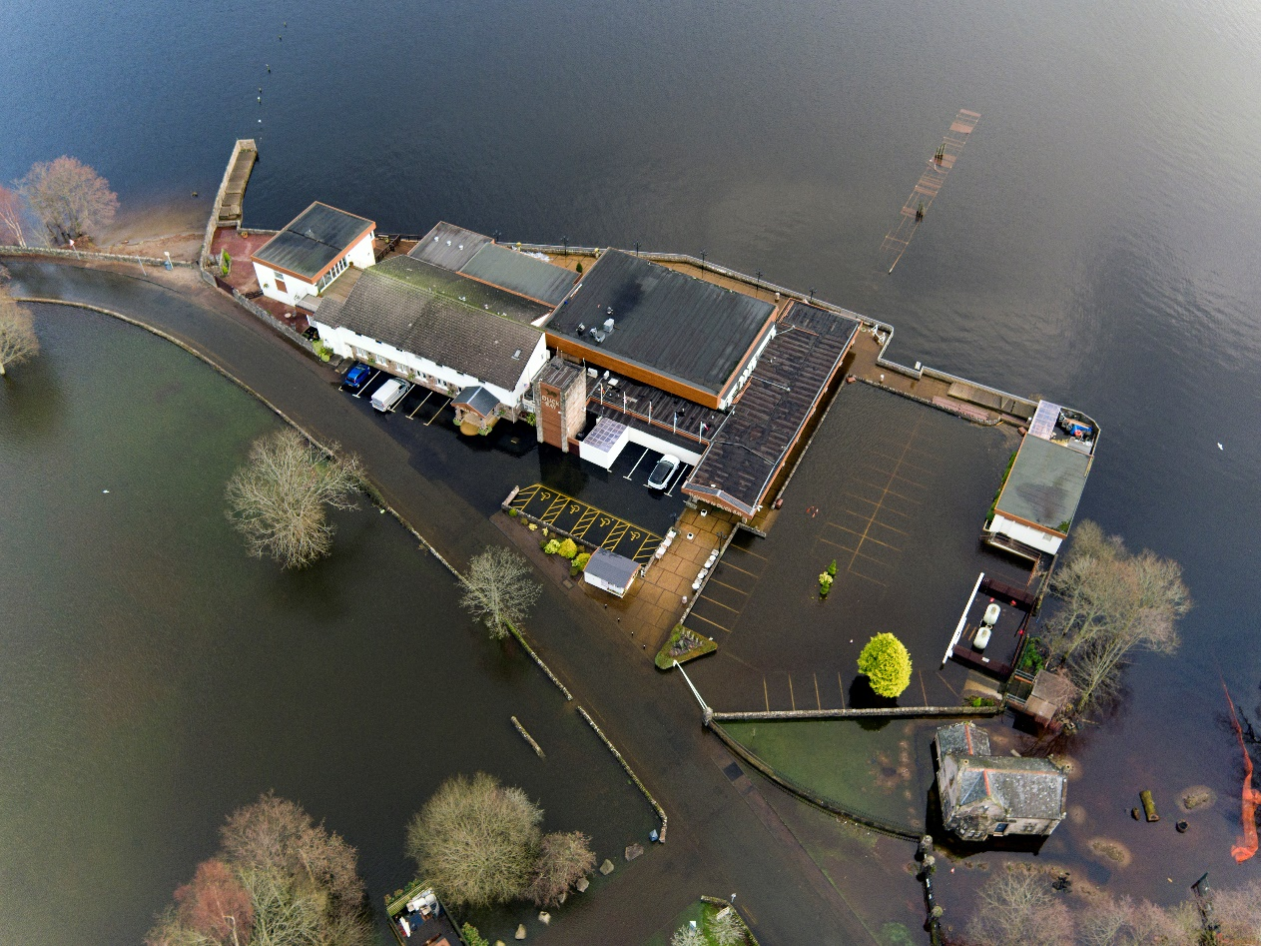

Duck Bay, Loch Lomond. Credit: Craig Jump

The High Street
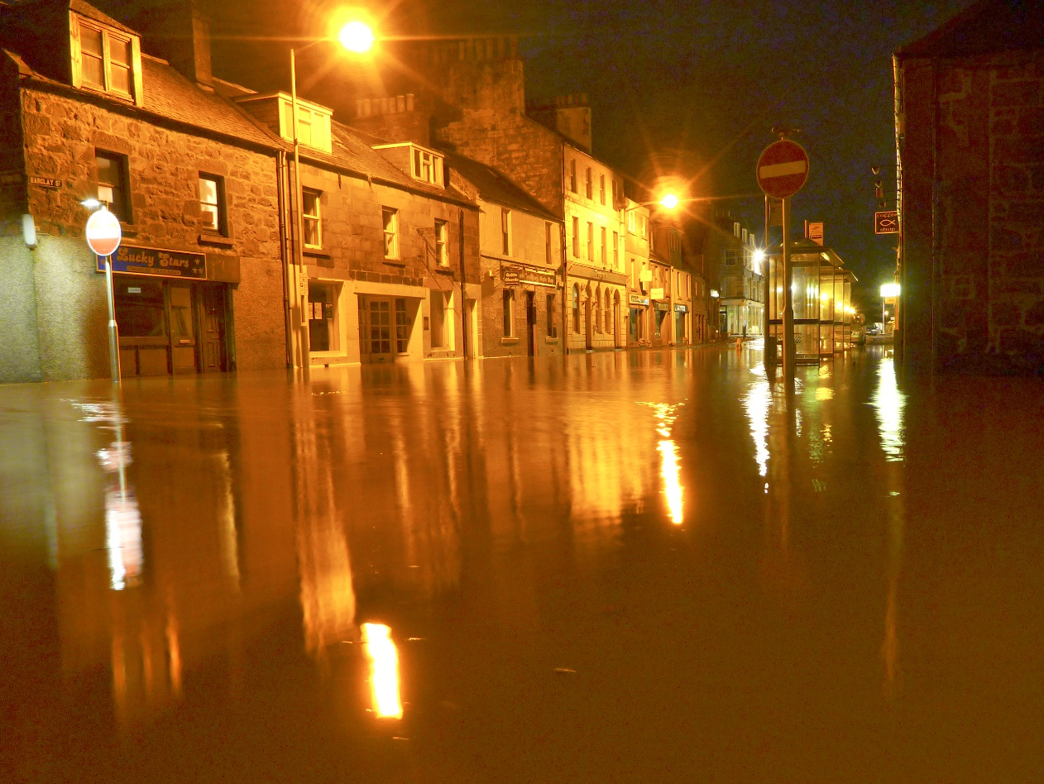

Stonehaven flood and aftermath, 2009. Credit: Will Munro

Plans

Menstrie Community Resilience Group Coordinating volunteers with Clacks Council Officer during the high water incident of June 2019. Credit: James Bull and Dave Sharp

Practice Makes Perfect
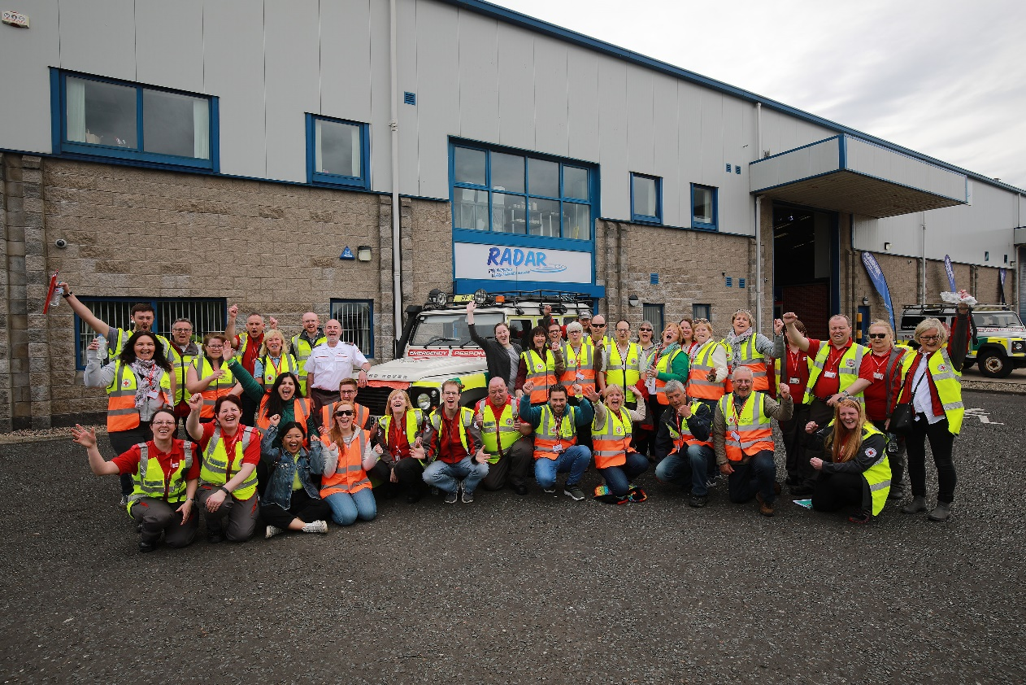

British Red Cross Emergency Response and Community Reserve Volunteers during an exercise. Credit: Nick Mort

No Barrier to Progress

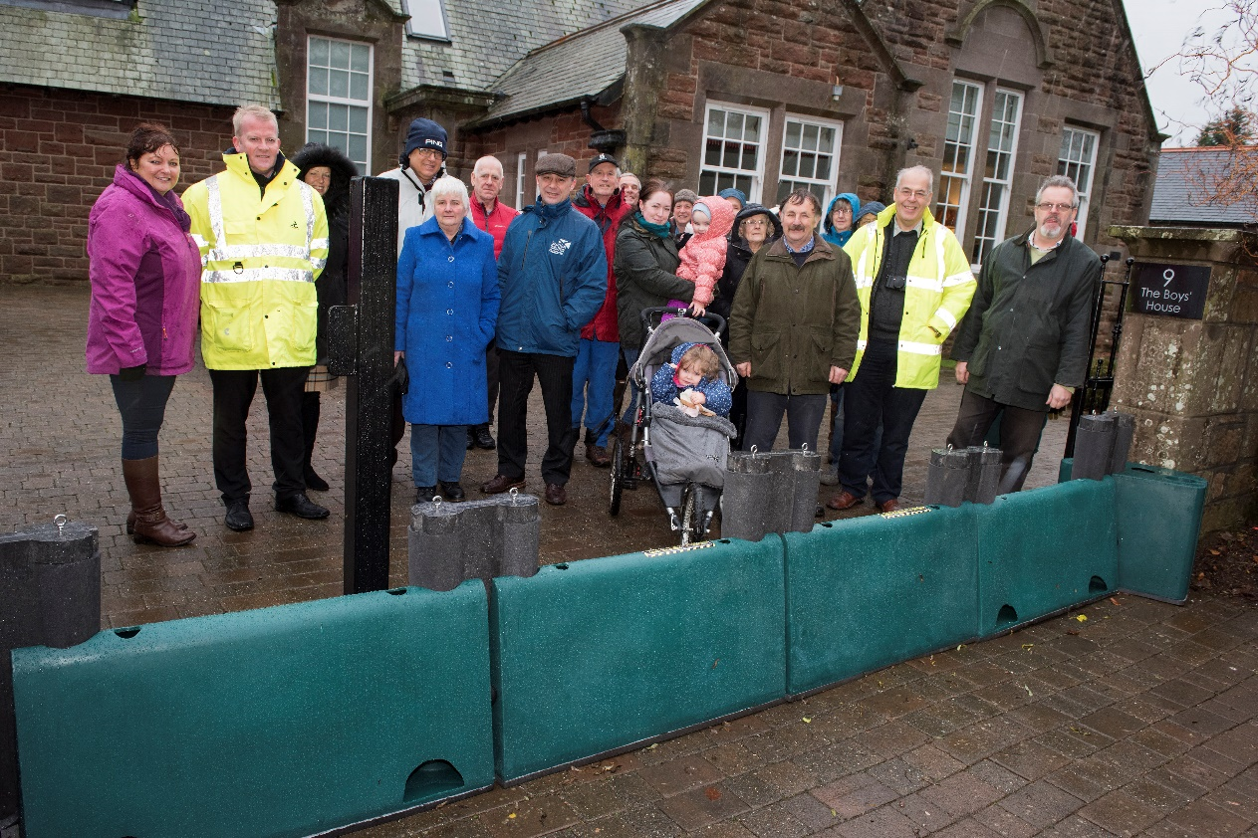
Scottish Flood Forum Edzell Flood Barrier, Angus. Credit: Paul Laidlaw

Follow the Path
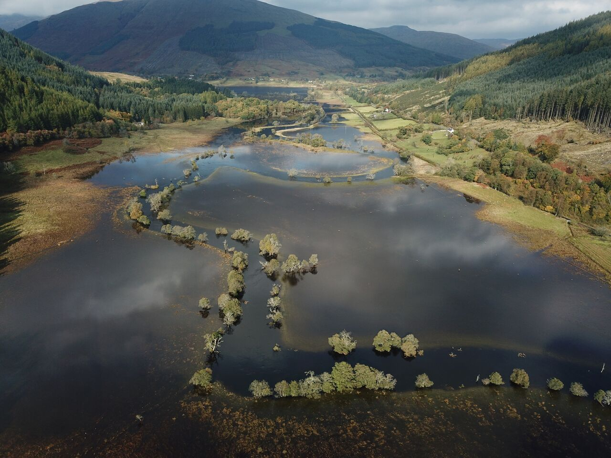

Mid Balvaig, Strathyre. Credit: K Higgins

Tackling Flooding Together
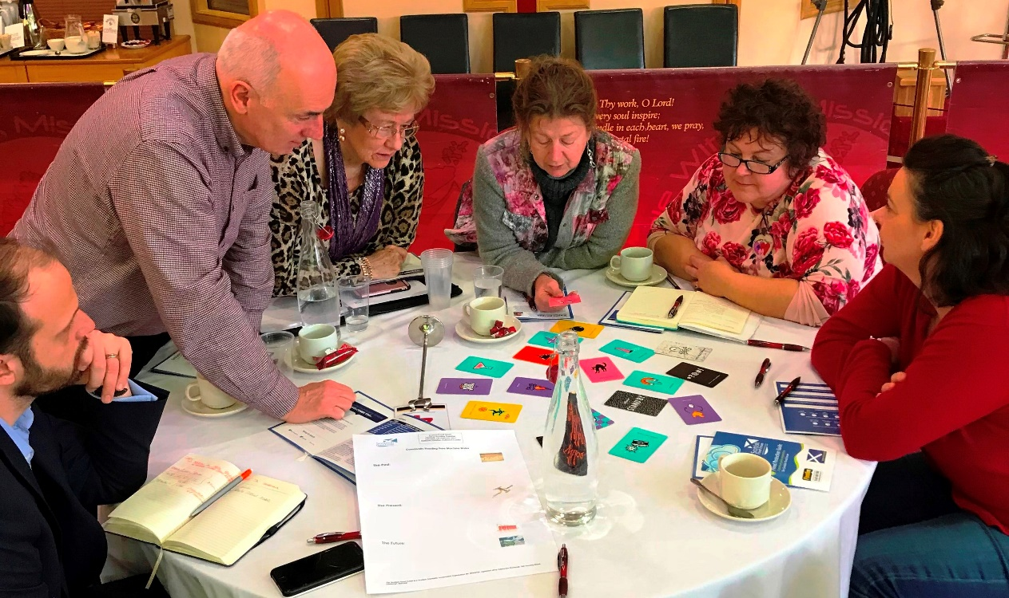

A community group discuss how best to tackle flooding with the Scottish Flood Forum. Credit: Paul Laidlaw

Health For All
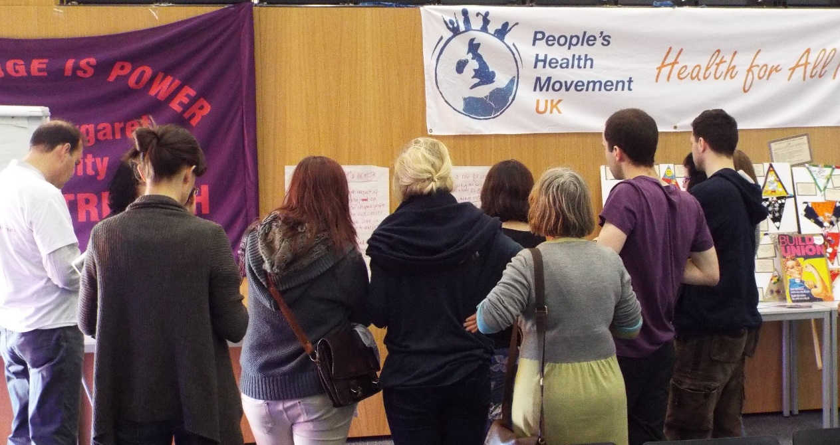

People’s Health Assembly, Edinburgh 2014. Credit: Tony Robertson

Resilience theatre 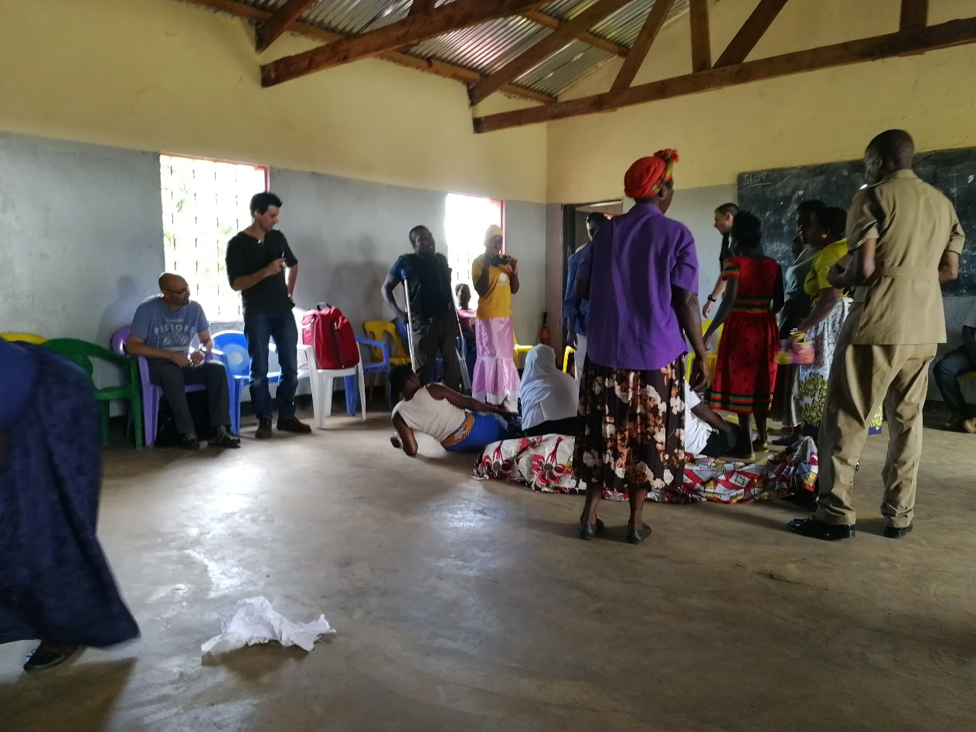

This photo was taken with consent by researchers on the Safe Roads Africa project at the University of Stirling. This is a partnership with The Polytechnic and Chancellor College at the University of Malawi and Glasgow School of Art. This project is promoting community resilience to respond to trauma from road traffic collisions which are common in Malawi, and difficult to address since there is no ambulance service in most rural areas. In this picture, community members were using theatre and role-playing to enact normal behaviours of community at the site of road traffic collisions. Following from this the research team discussed with Community members in this hot spot for accidents the changes which could be made to help save more lives. Theatre for development [using theatre, music and song] to raise awareness of issues and solutions to health related issues is very popular in Malawi and has been used for decades. Credit: Isabelle Uny

Water Break
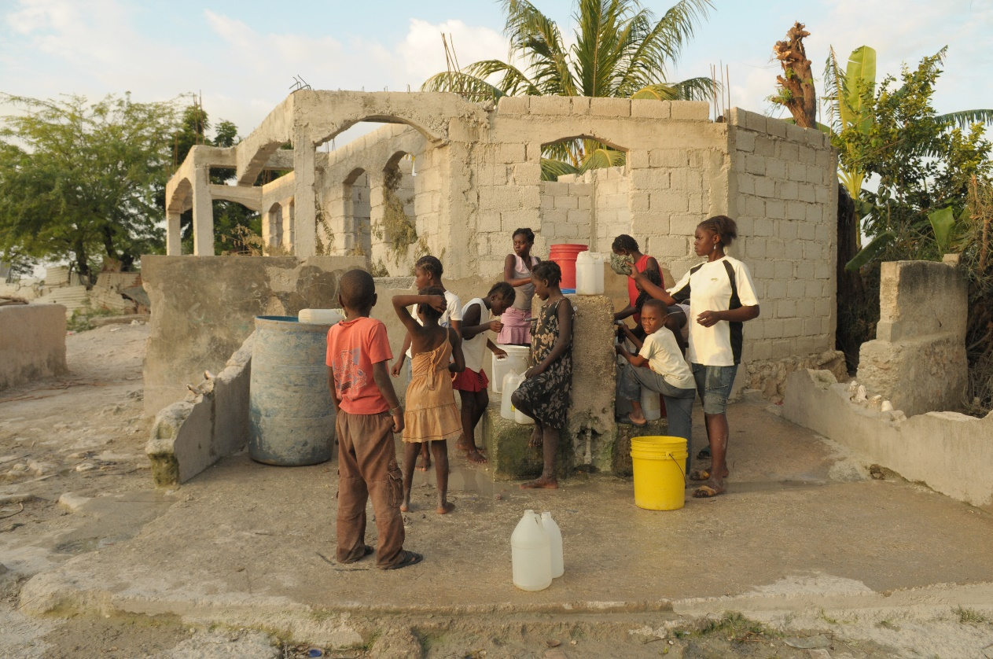

A family collect water in post-earthquake Haiti, 2010. The earthquake hit 15 miles southwest of the Haitian capital of Port-au-Prince on 12th January 2010. Haiti had not been hit by an earthquake of such enormity since the 18th century. It was estimated that around three million people were affected by the quake, approximately one-third of the country’s total population. Credit: Steve Lindridge
About
The research team are part of the Extreme Events research programme at the University of Stirling. The programme’s research focuses on how societies and ecosystems might better respond to extreme events and living with extreme circumstances. Living with extremes can range from experiencing terrorist attacks to flooding; disease outbreaks to political revolutions; poverty to forest fires. We seek to enhance resilience at all levels, from societal to individual, while embedding this resilience building around also tackling the fundamental social, environmental and economic drivers of extremes.
Sandra Engstrom is a Lecturer in Social Work with research interests in eco/green social work, including social work and natural disaster recovery/preparedness, social work and climate change/sustainability and eco therapy.
Fiona Millar is a Research Development Officer with research interests in the sociology of work and management of precarious careers.
Tony Robertson is a Lecturer in Social Epidemiology and Public Health with research interests in socioeconomic inequalities and the impact on physiology and health, and grassroots approaches to tackling health inequalities.
Contact Us
Twitter: @StirExtreme
Website: www.extremeevents.stir.ac.uk (includes a ‘contact us’ form)

